|  |  |
| --- | --- |
| **Title** | 4th homework in Python Programming class by 201923250 |

|  |  |  |  |
| --- | --- | --- | --- |
| **Author** | 201923250 | **Date** | 9.24.2020 |

**Summarization of the chapter 4**

A function is a block of code which only runs when it is called. You can pass data, known as parameters, into a function. A function can return data as a result. In Python, a function is a group of related statements that performs a specific task. Functions help break our program into smaller and modular chunks. In the case of a feature or method, parameters are the names used and arguments to be described. In other words, the arguments are those that are supplied to every calling function or method while their parameter names in the function or method code apply to the arguments.

**Coding challenge I did**

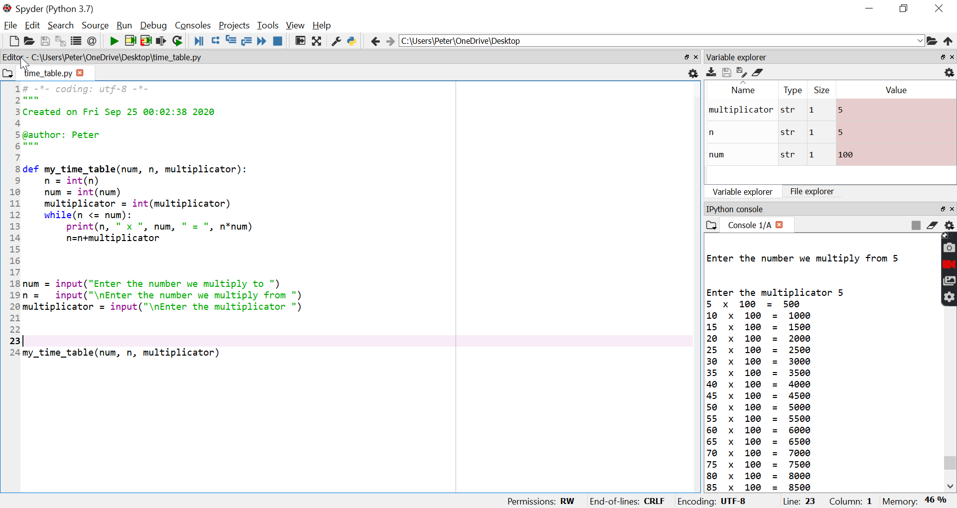

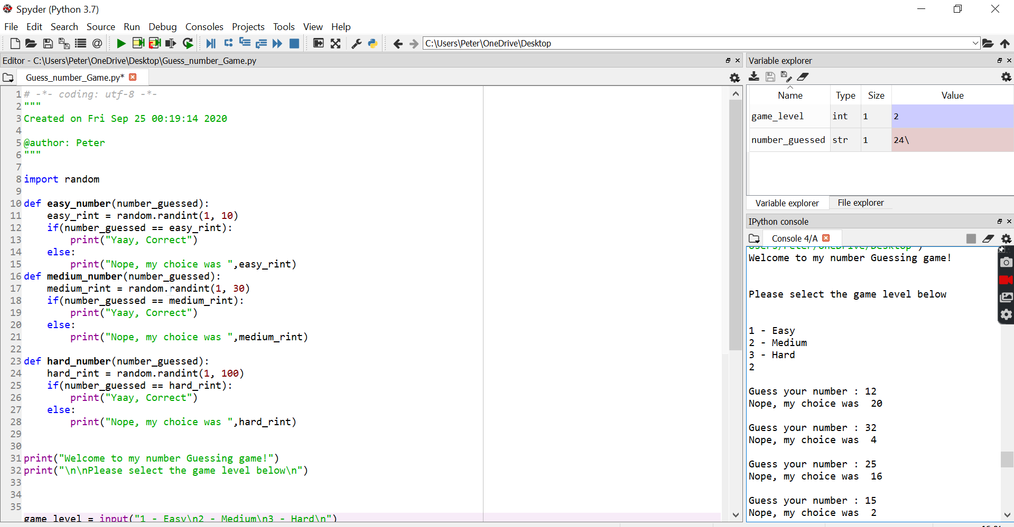

Thank you

Student ID : 201923250

Name : Kobilov Ilkhomjon